Lecture 2.2.2
Semigroup, Monoid

Course outcome to be covered:
CO1: Apply and recognized about the Semigroup, Monoid

Semigroup:
Semigroups are a simple functional concept which essentially allows us to take many objects and return a single object. It’s similar to reduce in that respect.
The most basic implementation of a semigroup is: (A, A) -> A . You might look at this and think, this would be perfect for an infix operator like +. You would be correct, in Haskell the operator is <> so as not to clash with existing + functionality, since the implementation may differ.
Semigroup is formulated by a finite or infinite set ‘S’ with the composition of a binary operation ‘o’. This composition is said to be semigroup if the following two conditions are satisfied to be true:
- Closure − For every pair (a,b)∈S,(aοb) has to be present in the set S.
- Associative − For every element a,b,c∈S, (aοb)οc=aο(bοc) must hold.

Example
For instance, the set o positive integers, apart from zero, with a binary operation of addition is said to be a semigroup. Say, S={1,2,3,…}.
For every pair, (a,b)∈S,(a+b) is present in the set S, and hence this holds true the closure property.
For example, 1+2=3∈S]
For every element a,b,c∈S,(a+b)+c=a+(b+c), hence holds true the associative property.
For example, (1+2)+3=1+(2+3)=5
Monoid:
The semigroup with an identity element is known as a Monoid. This identity element which is either denoted by E or e of a set S is also an element, such that (aοe)=a for every element of a∈S. The identity element may also be called as unit element.
Three properties such as Closure, Associative and the property of Identity elements holds by an monoid.
Example
The set of positive integers (excluding zero) with multiplication operation is a monoid. S={1,2,3,…}
For every pair (a,b)∈S,(a×b) is present in set S and hence holds true the closure property.
For example, 1×2=2∈S.
For every element a,b,c∈S,(a×b)×c=a×(b×c) holds true the associative property.
For example, (1×2)×3=1×(2×3)=6.
For every element a∈S,(a×e)=a, identity property also holds true.
For example, (2×1)=2,(3×1)=3. Here 1 is the identity element.
Group
A monoid with inverse element is known as a group. The inverse element I, is the element of the set S such that (aοI)=(Iοa)=a, for each of the element a∈S. It can be said that four properties can be hold by the group – Closure, Associative, Identity and Inverse. The number of elements in the group G is represented by the order of the group G.
Examples
Under the operation of matrix multiplication, the set of N×N non-singular matrices form a group.
Closure property holds true as the product of two N×N non-singular matrices is also an N×N non-singular matrix, thus holding true the associative property.
The set of N×N non-singular matrices contains the identity matrix holding the identity element property.
As all the matrices are non-singular they all have inverse elements which are also nonsingular matrices. Hence, inverse property also holds.

Abelian Group
A group for which the element pair (a,b)∈G always holds commutative is known as abelian group G, thus holding true five properties – Closure, associative, identity, inverse and commutative.
Example
The set of positive integers (including zero) with addition operation is an abelian group. G={0,1,2,3,…}
Here closure property holds as for every pair (a,b)∈S,(a+b) is present in the set S.
For example, 1+2=2∈S and so on
Associative property also holds for every element a,b,c∈S,(a+b)+c=a+(b+c)
For example, (1+2)+3=1+(2+3)=6
Identity property also holds for every element a∈S,(a×e)=a
For example, (2×1)=2,(3×1)=3. Here, identity element is 1.
Commutative property also holds for every element a∈S,(a×b)=(b×a)
For example, (2×3)=(3×2)=3
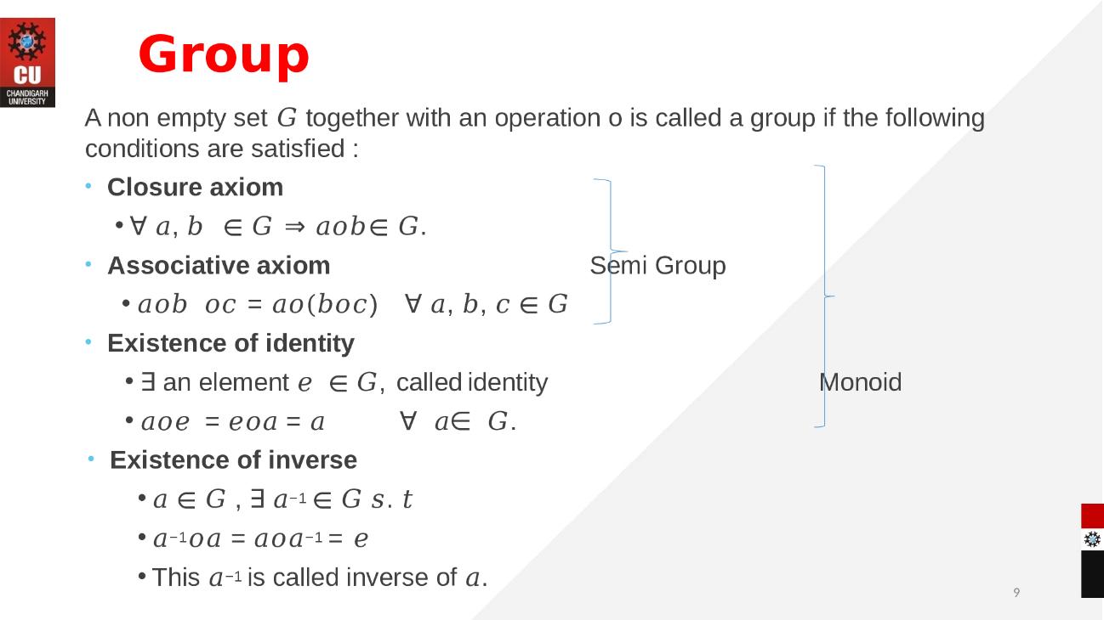

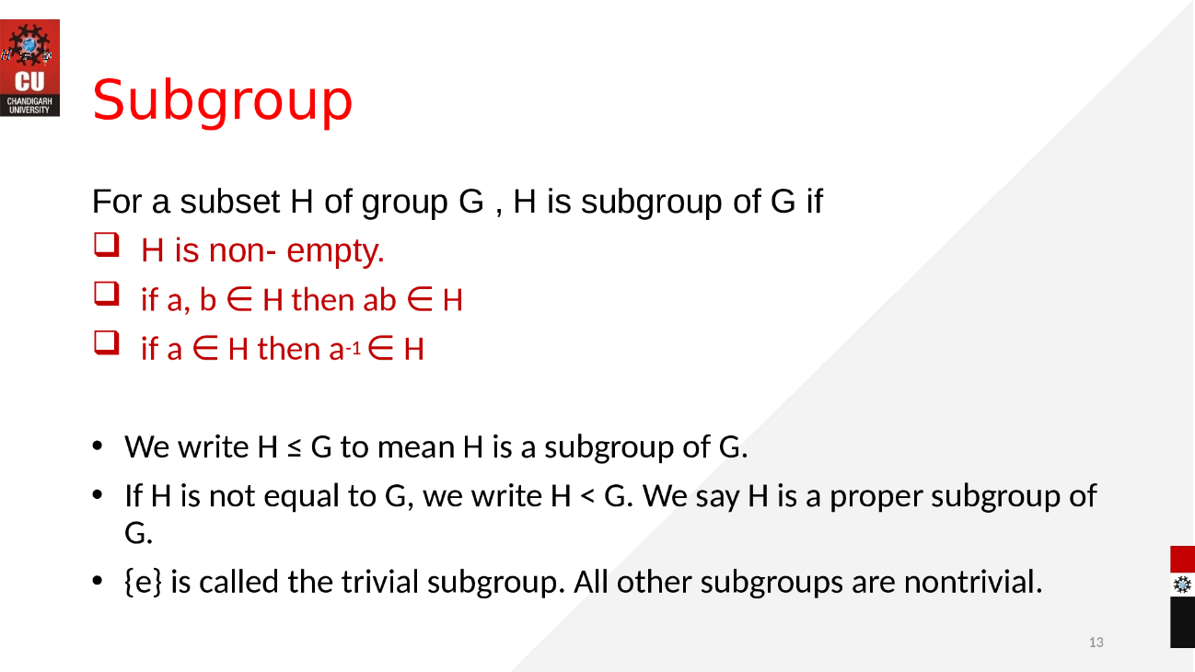

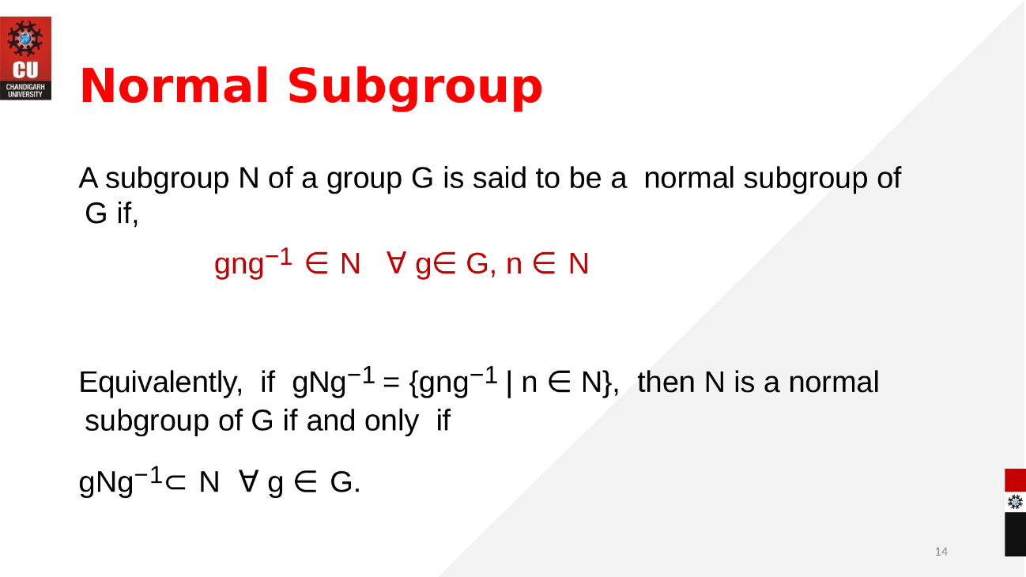

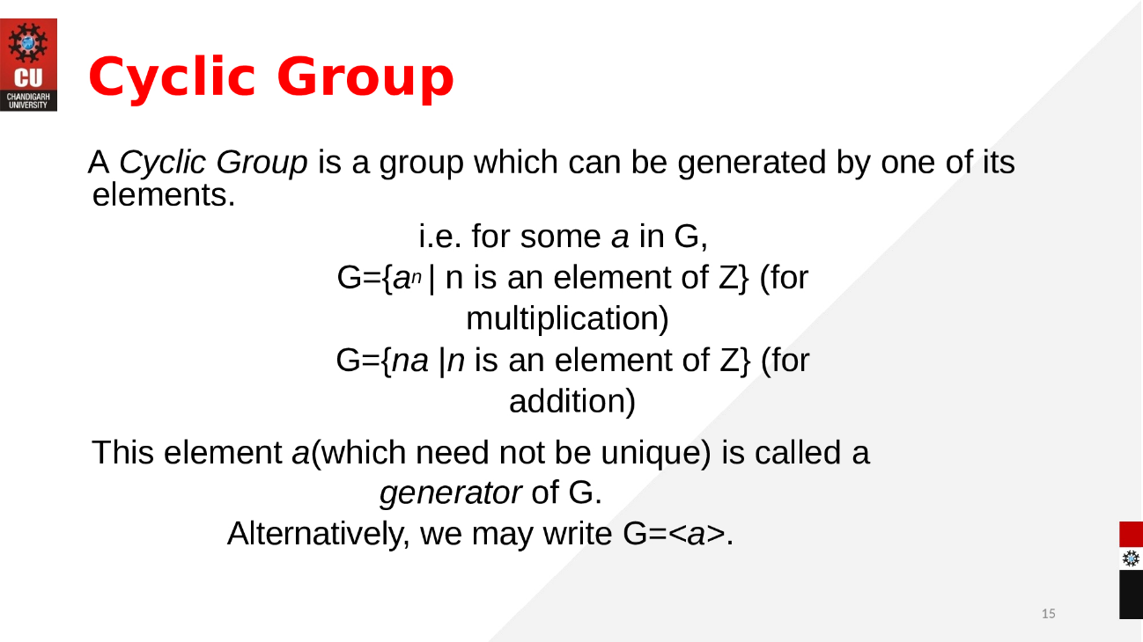

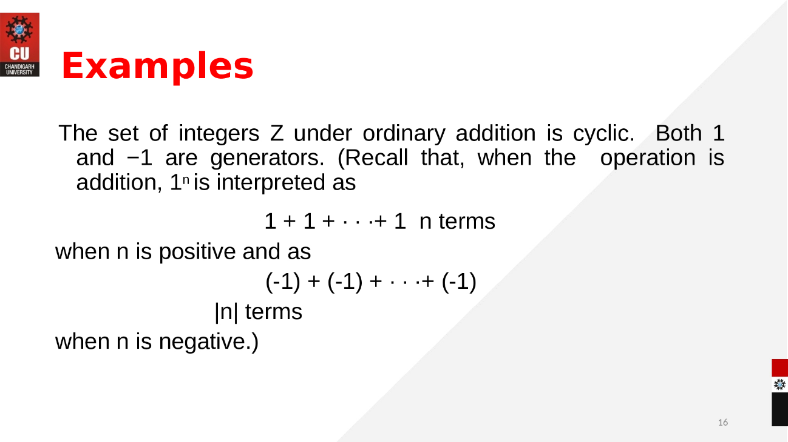

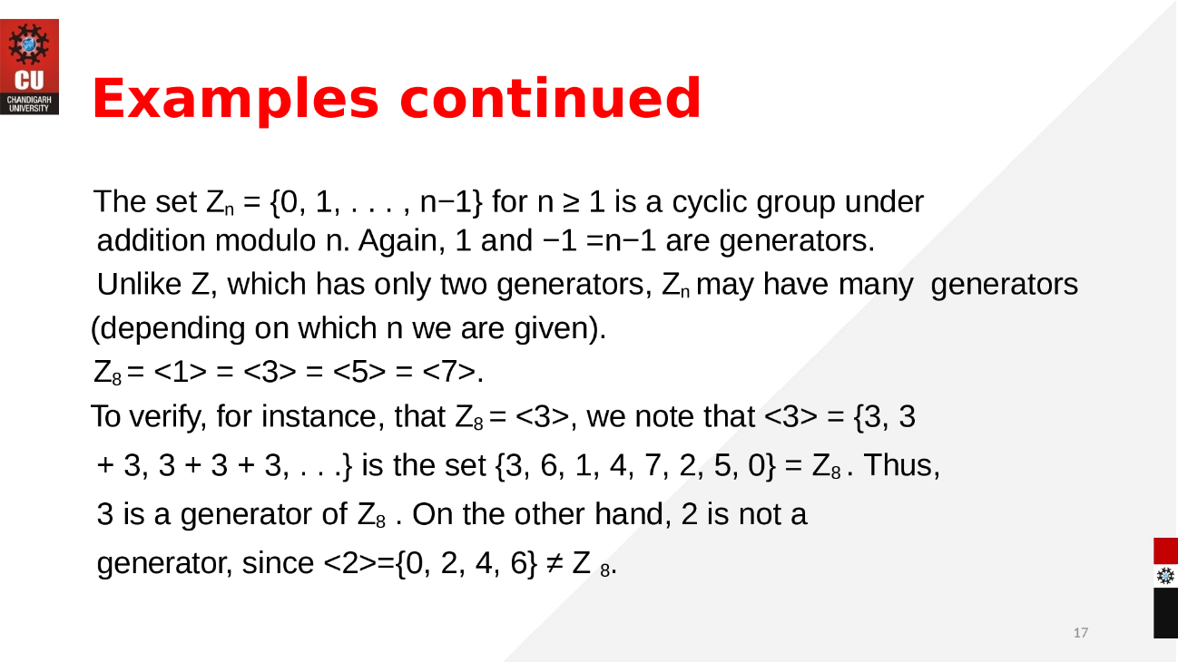

eBook Discrete Mathematics :
https://faculty.etsu.edu/gardnerr/5410/notes/I-1.pdf

Video link: https://www.youtube.com/watch?v=SgKpSDkRAug

